**PROJECT CHARTER**

|  |  |
| --- | --- |
| Atai Okokon | 434788 |
| Oluchi Ruth Osuafor-Humphrey | 458756 |
| Deepanshi | 456807 |
| Niriya | 454327 |

**Bow Valley College**

MGMT1103: Essential Skills for Teams Collaboration

Instructor: Hitesh Malik

March 15, 2024.

**INTRODUCTION**

Welcome to the exciting project of designing a super awesome BVC (Bow Valley College) app! In this project, we'll embark on a journey to create a mobile application that enhances the student experience at Bow Valley College. Teamwork will be our guiding principle as we collaborate to brainstorm, design, and implement features that cater to the diverse needs of our student community.

Teamwork is not just about working alongside others; it's about embracing different perspectives, communication styles, and motivations. As we navigate through this project, we'll practice empathy, active listening, and effective communication to ensure that every team member feels valued and heard.

**TEAM CHARTER WORKSHEET**

|  |  |
| --- | --- |
| **Team:** | CONNECT |
| **Date:** | MARCH 15, 2024 |

|  |  |
| --- | --- |
| **Members:** (Names) | **Team Meeting Roles/Responsibilities:** |
| Atai Okokon | Project Manager |
| Deepanshi | Lead Researcher |
| Niriya | Lead Programmer |
| Oluchi | Lead Data Scientist |
| **Team Mission:** (What is the purpose of your team? What is your objective?)  To work together in designing a functional and scalable mobile device app, we aim to provide tools and resources that support academic success, foster community engagement, and simplify campus life. Our goal is to create a platform that becomes indispensable to every student, contributing significantly to their overall college experience. | |
| **Conditions of Satisfaction:** (What are minimum requirements needed for completion of this project?)   * A fully functional mobile app that runs on all mobile platforms * An app that adds value to the BVC (Bow Valley College) student community. * Provide feedback on their courses, instructor and grade their over all learning experience. * Enables students to have access to learning materials, view their calendar and schedule study sessions, and notified them about the important dates. | |
| **Commitments:** (What are the commitments you are willing to make to one another?)  We agree to CONNECT!   * Committed- we will be committed to the team * Open- communicate openly and be respectful to each other * Non-Judgemental- accept each other without judgment * Nimble- quick, agile, adaptable * Efficient- work efficiently * Cordial- be cordial with each other * Timely- Do our work in a timely matter. | |

|  |
| --- |
| **Team Decisions:** (How will your team make decisions? What approach(es) you will use?)   * We will make decisions by voting. Where there is a tie, the Project Manager will make the decision. * We will openly communicate, collaborate, and share ideas with each other. * Tasks will be assigned based to each team member by the project manager. * After decisions are made, we will establish a feedback loop to evaluate their effectiveness and identify any necessary adjustments. By soliciting input from team members and stakeholders, we can continuously refine our decision-making processes and improve our overall effectiveness. |
| **Conflict:** (When conflict does happen, and it will, how will your team handle it?)   * Conflicts happen when there is no open communication. If there is an issue, the team member will discuss with the project manager who will ensure that conflicts are resolved as soon as possible. * We will view conflicts as opportunities for learning and growth, recognizing that constructive conflict can lead to innovation and improved team performance. After resolving conflicts, we will reflect on the experience, identify lessons learned, and implement changes to prevent similar conflicts in the future. * The team will try to resolve its own conflicts, however, if a team member continuously offends e.g. not participating or being disrespectful to others, the matter may be escalated to the Instructor. |
| **General Team Rules:** (What are the specific rules your team will adhere to?)   * Respect for one another. * Open Communication. * Timeliness e.g. in arriving for meetings and submitting assigned tasks * There will be consequences for not respecting the rules. * If you are late for meeting, you will buy lunch for the team (or send us amazon gift cards) * If you do not deliver your assigned tasks on time, you will get 2 warnings, after that, the instructor will be notified. |
| **Meeting/Work Schedule:** (What are the specific dates/days your team will meet?)   * To accommodate the availability of all team members, we will collectively agree on specific dates and times for our team meetings at the beginning of each week. Our standard meeting time will be on Tuesdays from 4:00 PM to 5:00 PM, and we will utilize Teams for our virtual meetings. * These meetings will serve as regular check-ins to discuss project progress, address any challenges or concerns, and plan upcoming tasks, deadlines, and charter will be updated. |

This Project charter was created by Team CONNECT

The undersigned agree to abide by this charter

|  |  |
| --- | --- |
| Atai Okokon | ATAI OKOKON |
| Oluchi Ruth Osuafor-Humphrey | OLUCHI RUTH OSUAFOR-HUMPHREY |
| Deepanshi | DEEPANSHI |
| Niriya | NIRIYA |

**REFERENCES**

No external references were used for this exercise. Our group met and discussed about it, and came up with the plans above.

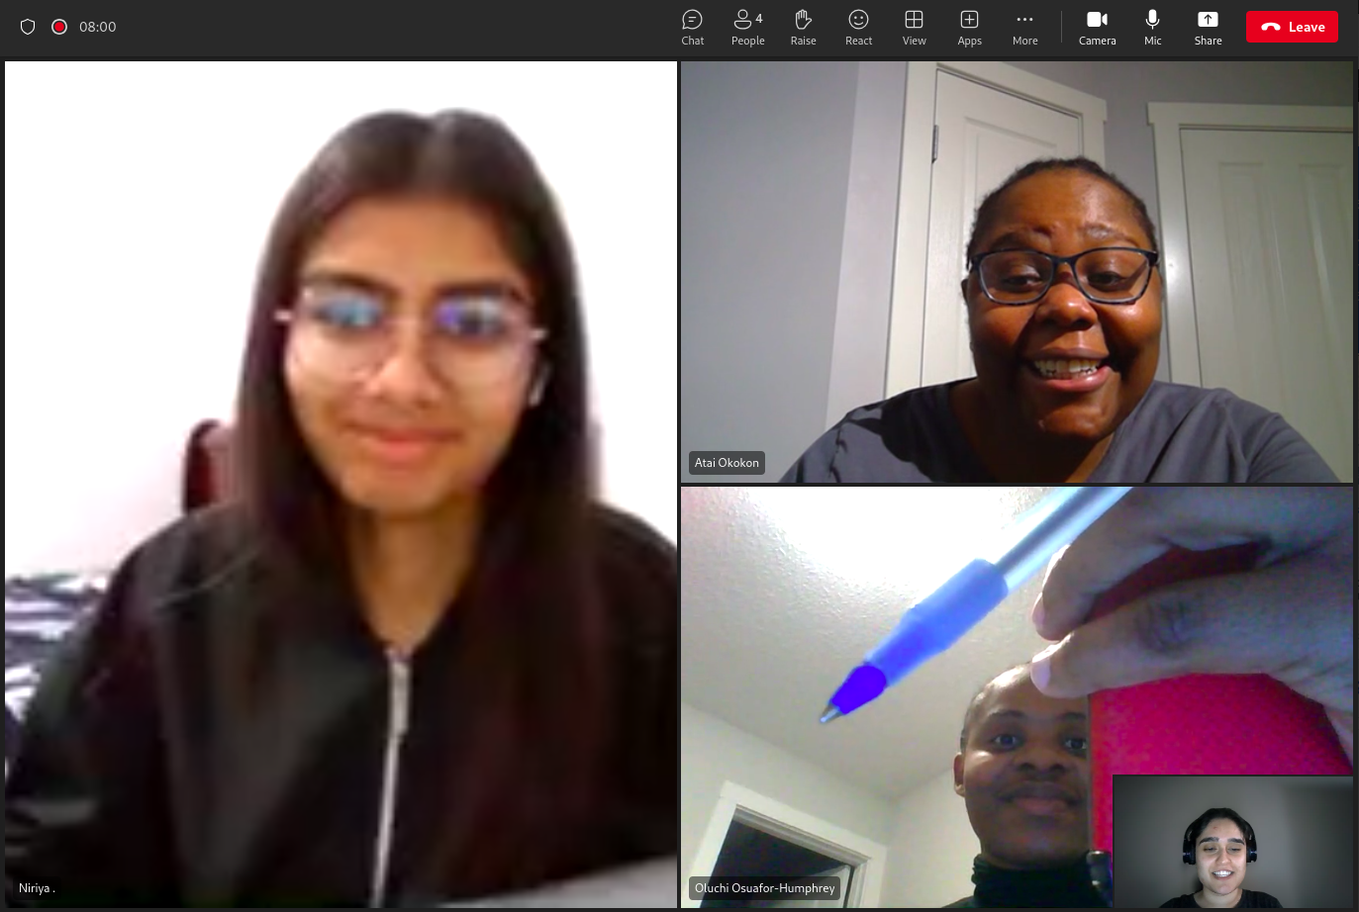

**Peer Evaluation**

**Use the rubic below to evaluate each participant**

|  |  |
| --- | --- |
| **Team Member** | **Score #** |
| Atai Okokon | 5 |
| Oluchi Ruth Osuafor-Humphrey | 5 |
| Deepanshi | 5 |
| Niriya | 5 |

|  |  |
| --- | --- |
| **Score 5** | Full Participation |
| **Score 4** | Good Participation |
| **Score 3** | Participated |
| **Score 2** | Minimal Participation |
| **Score 1** | No Participation |